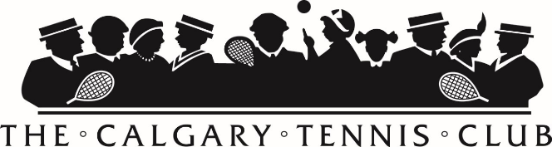
DRINKS
The Calgary Tennis Club
1445 16th St SW • Box 4504 Station C, Calgary. T2T 5N3
info@calgarytennisclub.com • (403) 244-5302
FB: The Calgary Tennis Club • IG: @calgarytennis
Alcoholic

CTC is proud to feature locally brewed, Calgary Craft Beers!

Craft Beer – Tall Boys 6
Cider - Tall Cans 6
Wine (6 oz) 6
Mixed Drink (1 oz) 6
Smirnoff Ice 6
Bottled Beer 5

Non-Alcoholic

Gatorade 3
Bottled Pop 2
Bottled Juice / Iced Tea 3
Water 1
Montellier 2
Club Soda / Tonic Water 1
O’douls Non-Alcoholic Beer 3

Calgary Tennis Club is pleased to support local small business!
The Calgary Tennis Club has been one of Calgary’s premier outdoor clubs since 1889. It is a friendly place to engage in competitive and social play, enhance your fitness potential, socialize with active people and bond with family members
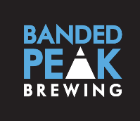
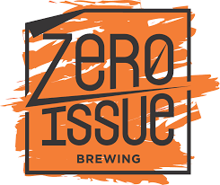
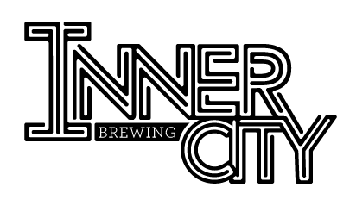
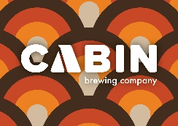

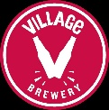

FOOD
All burgers and hot dogs come with your choice of chips

Hamburger 9
Lettuce, Tomato, Onion, Pickle
Cheeseburger 10
Sliced Cheese, Lettuce, Tomato, Onion, Pickle
Chicken Burger 10
Lettuce, Tomato, Onion, Pickle
Veggie Burger 9
Lettuce, Tomato, Onion, Pickle
Hot Dog 6
All beef

Grilled Cheese 4
Tuna Melt 8
Tuna, Shredded Cheese, Onion, Pickle, Choice of Bread
Naan Dippers 6
Mini Naan Dippers, Hummus
Chicken Caesar Salad 9
Grilled Chicken, Croutons, Parmesan Cheese, Caesar Dressing
“Pie Junkie” Hand Pie 6
Jamaican beef OR Italian job
“Pie Junkie” Savoury Pot Pie 10
Chicken pot pie; Steak and mushroom; Butter chicken; Cauliflower, potato, cheddar

SNACKS

Cliff Bar 2.5
Trail Mix 2
Chocolate Bar 1.5
Chips 1
Popcorn 1.5
Jumbo Freezie 1
Nutella & Go 2.5
m&m’s 3

